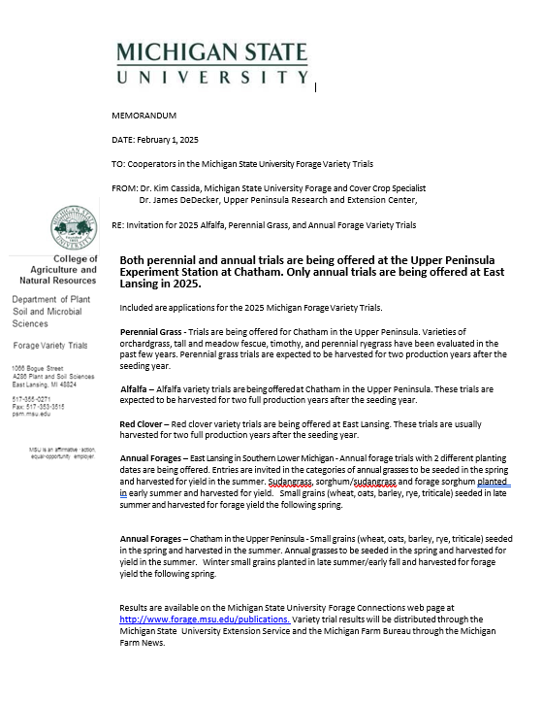
MICHIGAN ANNUAL FORAGE VARIETY TRIALS, 2025

James DeDecker  Michigan State University  Upper Peninsula Research and Extension Center  E3774 University Dr.  Chatham, MI 49816 | Kim Cassida  Michigan State University  Department of Plant Soil and Microbial Sciences  1066 Bogue Street, Plant and Soil Science Building  East Lansing, MI 48824

Michigan State University will accept proprietary varieties and experimental strains of annual forages for evaluation under rainfed conditions at East Lansing and Chatham.

- Description of Trials.

Location: Michigan State University Agronomy Farm, East Lansing, Michigan

Planting dates: Three planting dates.

- Spring (May planting): Annual/Italian/Intermediate ryegrass and other annual grasses, (summer harvest and a following spring harvest of surviving entries). Spring seeded small grains are harvested once for yield or twice if adequate regrowth occurs.
- Late Spring (Early June planting): Sudangrass, Sorghum x Sudangrass, Forage Sorghum planted and harvested 1 or 2 times.
- Late Summer or September planting: winter small grains (spring harvest)

Location: MSU Upper Peninsula Research and Extension Center, Chatham, Michigan

Planting dates: Two planting dates.

- Spring (May planting): Annual/Italian/Intermediate ryegrass and other annual grasses, (summer harvest and a following spring harvest of surviving entries).
Spring seeded small grains (harvested once for yield or twice if adequate regrowth occurs).
- Late Summer or September planting: winter small grains (spring harvest)

Data Collected: Yield

Trials are seeded with either a Carter small plot nursery seeder or a tractor mounted research drill in plots 4 feet wide and at least 20 feet long. A minimum of four replications is used. The trials are harvested for yield by cutting the center 3 feet with a Carter self-propelled forage flail harvester at a time appropriate for optimum yield. All trials are managed for high yield using MSU recommendations for fertility, weed, and pest control under natural rainfall.

Michigan State University will conduct the trials in a professional manner but assumes no financial liability for failure to obtain stands or loss of stands due to uncontrollable conditions.

- Eligibility of Entrants. Any entity may enter varieties, experimental strains, blends, or mixtures in the test provided they have legal permission to do so for protected varieties. This includes private or public developers, dealers, distributors or merchandisers of alfalfa varieties, other Agricultural Experiment Stations, non-profit groups, farmer cooperatives, or individuals.

- Rejection. Any entry may be rejected if:
  - The trial is cancelled. A minimum of 10 entries per test location may be required to hold a test.
  - There is misrepresentation.
  - Seed arrives too late for planting.
  - Adequate seed is not available.
  - Documentation of species/variety proportion in mixtures and blends is not provided.

- Entry Fee. $300.00 per entry.
Applications and seed may be sent to: Checks payable to Michigan State University Forage Testing

James DeDecker, Michigan State University Upper Peninsula Research and Extension Center,
E3774 University Drive, PO Box 168, Chatham, MI 49816 dedecke5@msu.edu

or

Joe Paling, 4450 Beaumont Rd, Michigan State University Agronomy Farm, Lansing, Michigan 48910
paling@msu.edu

Deadline for Entry. Applications and seed for Spring seeded Tests should be received by April 26, 2024. Applications and seed for Late Summer Tests should be received by August 30, 2024.

- Seed Required. Seed for released varieties is to be from a commercial source. Arrangements may be made with MSU to deliver commercial seed through local dealers, distributors, or other sources. If germination rates are above 90% the following weights per trial apply:

Annual Grass – Multiple-cut Trial, East Lansing or Chatham

Ryegrass (Annual, Italian, or Intermediate) – 200 g seed per location
Teffgrass – 100 g seed per location
Crabgrass – 100 g seed per location

Spring Seeded Small Grain Forages – Single-cut trials, Chatham

Barley, Oats, Rye, Triticale – 600 grams per entry per location

Warm Season Grass – Multiple-cut Trial, East Lansing

Sudangrass, Sorghum x Sudangrass, Forage Sorghum – 200 g seed

Winter Small Grain Forage – Late Summer seedings, East Lansing or Chatham

Wheat, Triticale, Rye, Hybrid Rye, Barley – 600 g seed per entry per location

- Publication. Each entrant will receive a yearly summary of the data in December, including all released and experimental varieties. The yearly summaries will be published in the January 30th edition of the Michigan Farm News. Complete test results will be published by Michigan State University Extension and will be posted on the MSU Forage Connection website http://www.forage.msu.edu/publications.

- For assistance, contact James DeDecker dedecke5@msu.edu, 906-439-5114, or Christian Kapp kappchri@msu.edu at Chatham. Kim Cassida cassida@msu.edu, 517-353-0278, or Joe Paling paling@msu.edu at East Lansing.

MICHIGAN ANNUAL FORAGE VARIETY TRIALS, 2025

James DeDecker and Christian Kapp  Michigan State University  Upper Peninsula Research and Extension Center  PO Box 168, E3774 University Drive  Chatham, MI 49816 | Kim Cassida and Joe Paling  Department of Plant Soil and Microbial Sciences  1066 Bogue Street, Plant and Soil Science Building  Michigan State University  East Lansing, MI 48824

Submit one form for each variety or entry and send to the address below with entry fee of $300 per entry, location, and planting date. Entries for spring planting date should be received by April 26. Entries for late summer planting date should be received by August 30.

Seed of the following amounts (per location and Planting Date) is required.
Annual Forages – Late Spring/early summer seeding

Ryegrass (Annual, Italian, or Intermediate) – 200 g seed, Crabgrass – 100 g seed, Teffgrass – 100 g seed
Wheat, Barley, Oats, Rye, Hybrid Rye, Triticale – 600 grams per entry per location
Sudangrass, Sorghum x Sudangrass, Forage Sorghum – 200 g seed

Winter Small Grain Forage – Late Summer seedings

Wheat, Barley, Rye, Hybrid Rye, Triticale – 600 grams per entry per location

Marketer (commercial entries only) Breeder

Company
Company

Contact
Contact

Address
Address

City, State ZIP
City, State ZIP

Phone/FAX
Phone/FAX

E-Mail address
E-Mail address

- Name of entry
(Please indicate name desired when data are reported)
- Brief description _____________________________________________________________________
___________________________________________________________________________________

- Is this a released variety? Yes_______ No _________
- Maturity (circle one) Early Medium Medium-late Late
- Ploidy level (Ryegrass)
- Rust Resistance Yes______ No ________
- Germination __________ Purity ___________ Date of Test _______________
Locations -- $300.00 per entry per Location and Planting Date combination
Chatham _________ Planting Date: Spring ________
East Lansing ______ Planting Date: Spring _____ Early Summer _____ Late Summer ________

Michigan State University: Kim Cassida at cassida@msu.edu, 517-353-0278 or James DeDecker at dedecke5@msu.edu, 906-439-5114.

