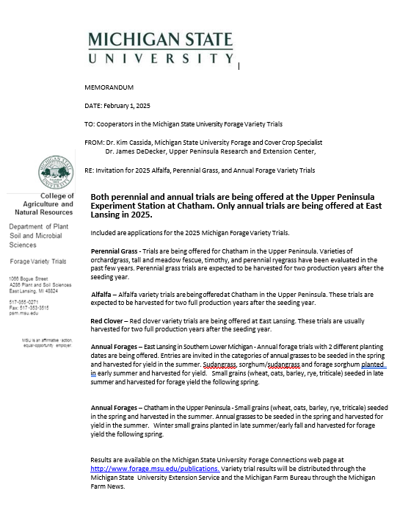
MICHIGAN PERENNIAL GRASS FORAGE VARIETY TRIALS, 2025

James DeDecker  Michigan State University  Upper Peninsula Research and Extension Center  PO Box 168, E3774 University Drive  Chatham, MI 49816 | Kim Cassida  Michigan State University  Department of Plant Soil and Microbial Sciences  1066 Bogue Street, Plant and Soil Science Building East Lansing, MI 48824

Michigan State University will accept proprietary varieties and experimental strains of alfalfa for evaluation at one location in 2025. The trials are intensively managed for high yield under high fertility, utilizing all factors to maximize yield under natural rainfall.

- Locations for 2025
  - MSU Upper Peninsula Research and Extension Center at Chatham, approximately 300 miles north of East Lansing. Chatham has cold winters with deep snow cover. Winter-hardiness and persistence are important at Chatham. Chatham trials are managed for three cuttings from June to October.

- Description of Trials: Trials are usually seeded in plots 5 feet wide and at least 18 feet long (generally 20-23 feet). The center 3 feet will be harvested for yield with a Carter self-propelled forage flail harvester. A minimum of four replications will be used. Grasses are managed for maximum yield under rainfed conditions with fertility and pest control according to MSU recommendations.

Standard procedures for determining dry matter yield are used. Plots will be harvested for at least two years after the seeding year unless stands are injured by uncontrollable causes. Preferably, grass will be seeded in the spring and harvested at once in the seeding year. Seeding may be delayed until late July or early August to achieve the best results in stand establishment, in which case seeding year harvests may not be taken.

Michigan State University will conduct the trials in a professional manner, but assumes no financial liability for failure to obtain stands or loss of stands due to uncontrollable conditions.

- Eligibility of Entrants. Any entity may enter varieties or experimental strains in the test provided they have legal permission to do so for protected varieties. This includes private or public developers, dealers, distributors or merchandisers of grass varieties, other Agricultural Experiment Stations, non-profit groups, farmer cooperatives, or individuals.

- Rejection. Any entry may be rejected if:
  - The trial is cancelled. A minimum of 10 paid entries (excluding check varieties) will be required to hold a test at a location.
  - There is misrepresentation.
  - Seed arrives too late for planting.
  - Adequate seed is not available.
  - Seed is a blend.

- Entry Fee. Yield comparisons at Chatham, $480.00 per entry
Applications and seed for the perennial grass trial may be sent to:
Checks payable to Michigan State University Forage Testing

James DeDecker, Michigan State University Upper Peninsula Research and Extension Center,
E3774 University Drive, PO Box 168, Chatham, MI 49816 dedecke5@msu.edu

or

Joe Paling, 4450 Beaumont Rd, Michigan State University Agronomy Farm, Lansing, Michigan 48910
paling@msu.edu.

Deadline for Entry. Applications must be received by April 5, 2025. Seed should be received by April 26, 2025.

- Seed Required. Seed for released varieties is to be from a commercial source. Arrangements may be made with MSU to deliver commercial seed through local dealers, distributors, or other sources. If germination rates are above 90%, the following seed weights apply:

Fescues – 200 g seed Orchardgrass – 200 g seed
Perennial Ryegrass – 200 g seed Festulolium – 300 g seed
Bromegrasses – 300 g seed Timothy – 100 g seed

For other species, contact us for instructions before sending seed.

Publication. Each entrant will receive a yearly summary of the data in December, including all released and experimental varieties. The yearly summaries will be published in the January 30th edition of the Michigan Farm News. Complete test results will be published by Michigan State University Extension and will be posted on the MSU Forage Connection website http://www.forage.msu.edu/publications.

- For assistance, contact James DeDecker dedecke5@msu.edu, 906-439-5114, or Christian Kapp kappchri@msu.edu at Chatham. Kim Cassida cassida@msu.edu, 517-353-0278, or Joe Paling paling@msu.edu at East Lansing.

MICHIGAN 2025 PERENNIAL FORAGE GRASS VARIETY TRIALS

James DeDecker and Christian Kapp  Michigan State University  Upper Peninsula Research and Extension Center  PO Box 168, E3774 University Drive  Chatham, MI 49816 | Kim Cassida and Joe Paling  Michigan State University  Department of Plant Soil and Microbial Sciences  1066 Bogue Street, Plant and Soil Science Building  East Lansing, MI 48824

Submit one form for each variety or entry and send to the address below by April 5, 2025. Seed of the following amounts (per location) should be received by April 26, 2025.

Fescues – 200 g seed Orchardgrass – 200 g seed
Perennial Ryegrass – 200 g seed Festulolium – 300 g seed
Bromegrasses – 300 g seed Timothy – 100 g seed

For other species or mixtures, contact us for instructions before sending seed.

- Name of applicant

Contact Person E-mail

Would you like a paper copy of the results, in addition to the Excel file that is sent via email? Yes No

- Address
City State Zip
Phone ( ) Fax ( )

- Name or number of entry (Please indicate name desired when data are reported)

- Brief description

Is this a released variety? Yes No If, Yes: Marketer in Michigan

- Maturity (circle one)
Early Medium Medium-late Late

6. Ploidy level, Perennial Ryegrass

7. Rust Resistance (Ryegrass and Orchardgrass) Yes No

Germination % Date of test
Purity Perennial Grass $480.00 per Entry

Michigan State University: James DeDecker at dedecke5@msu.edu, 906-439-5114 or Kim Cassida at cassida@msu.edu, 517-353-0278.

