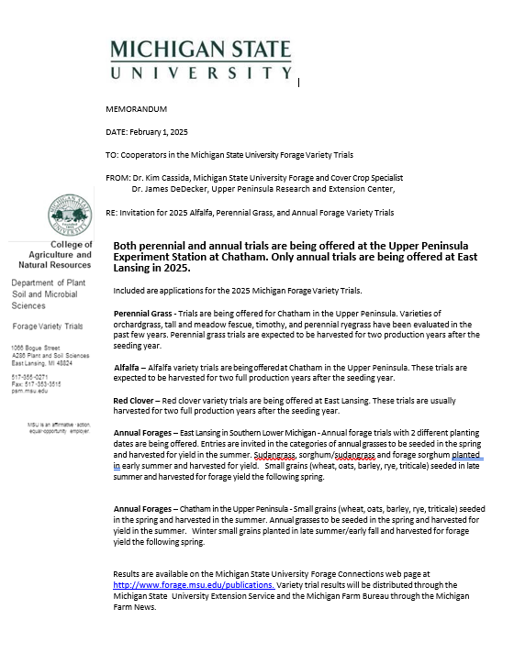
MICHIGAN RED CLOVER VARIETY TRIALS, 2025

James DeDecker  Michigan State University  Upper Peninsula Research and Extension Center  E3774 University Dr.  Chatham, MI 49816 | Kim Cassida  Michigan State University  Department of Plant Soil and Microbial Sciences  1066 Bogue Street, Plant and Soil Science Building  East Lansing, MI 48824
Michigan State University will accept proprietary varieties and experimental strains of red clover for evaluation at Chatham in 2025.

- Locations for 2025
  - MSU Upper Peninsula Research and Extension Center at Chatham, approximately 300 miles north of East Lansing. Chatham has cold winters with deep snow cover. Winter-hardiness and persistence are important at Chatham. Chatham trials are managed for three cuttings from June to October.

- Description of Trials. Trials are seeded with a five-row nursery seeder with six-inch spaces between rows in plots 3 feet wide and at least 20 feet long (generally 22-25 feet). A minimum of four replications is used. Plots are harvested with a Carter self-propelled forage flail harvester.

Standard procedures for determining dry matter yield are used. Plots will be harvested for at least two years after the seeding year unless stands are injured by uncontrollable causes. Preferably, red clover will be seeded in the spring and harvested one or two times in the seeding year. Seeding may be delayed until late July or early August to achieve best results in stand establishment. Post-emergence herbicides may be used for weed control during the establishment year.

Data on stand longevity, disease reaction, and maturity will be obtained when appropriate. Michigan State University will conduct the trials in a professional manner, but assumes no financial liability for failure to obtain stands or loss of stands due to uncontrollable conditions.

- Eligibility of Entrants. Any entity may enter varieties or experimental strains in the test provided they have legal permission to do so for protected varieties. This includes private or public developers, dealers, distributors or merchandisers of red clover varieties, other Agricultural Experiment Stations, non-profit groups, farmer cooperatives, or individuals.

- Rejection. Any entry may be rejected if:

  - The trial is cancelled. A minimum of 8 paid entries (excluding check varieties) will be required.
  - There is misrepresentation.
  - Seed arrives too late for planting.
  - Adequate seed is not available.
  - Seed is a blend.

- Entry Fee. Yield comparisons at Chatham, $480.00 per entry
Applications and seed for the Red Clover alfalfa trial may be sent to:
Checks payable to Michigan State University Forage Testing

James DeDecker, Michigan State University Upper Peninsula Research and Extension Center,
E3774 University Drive, PO Box 168, Chatham, MI 49816 dedecke5@msu.edu

or

Joe Paling, 4450 Beaumont Rd, Michigan State University Agronomy Farm, Lansing, Michigan 48910
paling@msu.edu.

Deadline for Entry. Applications should be received by April 5, 2025. Seed should be received by April 26, 2025.

- Seed Required. Seed should be received by April 26, 2025. Arrangements may be made with MSU to deliver commercial seed through local dealers, distributors, or other sources.

Released varieties: 200 grams of seed per entry.
Experimentals: 100 grams is adequate.
Seed treated with a fungicide will be accepted. Seed will be inoculated with Rhizobium at MSU prior to planting.

- Publication. Each entrant will receive a yearly summary of the data in December, including all released and experimental varieties. The yearly summaries will be published in the January 30th edition of the Michigan Farm News. Complete test results will be published by the Michigan Agricultural Experiment Station or the Michigan State University Extension Service and will be posted on the MSU Forage Connection website http://www.forage.msu.edu/publications.

- For assistance, contact James DeDecker dedecke5@msu.edu, 906-439-5114, or Christian Kapp kappchri@msu.edu at Chatham. Kim Cassida cassida@msu.edu, 517-353-0278, or Joe Paling paling@msu.edu at East Lansing.

MICHIGAN 2025 RED CLOVER VARIETY TRIAL

James DeDecker and Christian Kapp  Michigan State University  Upper Peninsula Research and Extension Center  PO Box 168, E3774 University Drive  Chatham, MI 49816 | Kim Cassida and Joe Paling  Department of Plant Soil and Microbial Sciences  1066 Bogue Street, Plant and Soil Science Building  Michigan State University  East Lansing, MI 48824

Submit one form for each variety or entry and send to the address below by April 5, 2025.
Seed of released varieties (200 grams from a commercial source) and experimental entries (100 grams per location) should be received by April 26, 2025. Only genetically reproducible seed will be accepted.

- Company

Contact person Marketer

Email

- Address

City State Zip

Phone ( ) Fax ( )

- Name or number of entry (Please indicate name desired when data are reported)

- Brief description

- Is this a commercially released variety? Yes No

- Disease Resistance _______________________________________________________________

Please list any additional e-mail addresses you would like the results sent to:

Date of Seed Test ______________________
Purity
Germination, quick
Germination, total
Scarified - yes or no (circle one)

Michigan State University: Kim Cassida at cassida@msu.edu, 517-353-0278 or James DeDecker at dedecke5@msu.edu, 906-439-5114.

